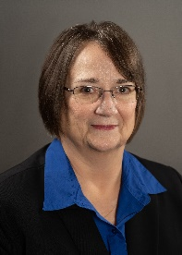VFW Auxiliary

Department of Missouri

January/February Newsletter

**Message from Department President Judi Linneberger**

Happy New Year Everyone. I hope your holiday season was a great one.

As you know the Commander in Chief and National President have a joint special project. It is the renovation of a building on the campus of the National Home to make a convenience store for the residents of the National Home. If you haven’t donated to this, it would be a great start to the new year to send a donation to Department Treasurer Jackie Davis and earmark it for the *National Commander N Chief and National President’s Special Project*. Commander Charles and I thought that once the convenience store is up and running there would be a continuing need for resources to keep the store stocked. To this end our joint project for this year is to raise funds for the continued stocking of the convenience store. Please consider donating and sending it to Department Treasurer Jackie and earmark it ***Missouri Commander and President’s joint project 23-24.***

The Winter Conference is coming up February 9-10, 2024, in Columbia. If you haven’t already made your hotel reservations and sent in for your banquet tickets, now is the time to do so. Don’t miss out on hearing the Voice of Democracy winning speech. It is always a great time seeing everyone dressed in their finest.

How is your auxiliary doing in membership? Are you over 100%? We MUST keep getting those dues in and recruiting new members. Our organization will not survive without members. You know that recruiting 5 members will get you a pin sent straight from National. No counting needed. I’ve put out a membership challenge. The first district to make 100% in membership will receive $100 from me. The Auxiliary in that District that has the highest percentage when the district reaches 100% will receive $50 from me. Let’s see who gets my money.

I believe that National President Carla’s visit in November was a fun time for all that attended. Photos from our wonderful historian Rai are on the reverse side of this newsletter.

Valentines are always welcomed by our Veterans, whether in the hospital, Veterans Home, or nursing home. Get the youth involved and see the smiles on the Veteran’s faces when the are presented to them.

AND……

“Show Me Teamwork….as we serve our Veterans” by “Banding Together for our Veterans”.

Auxiliary Features

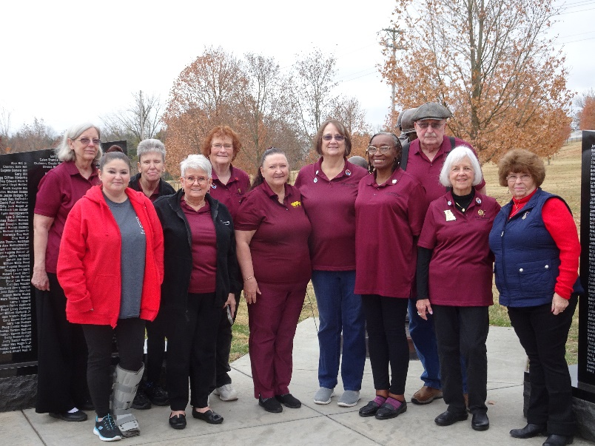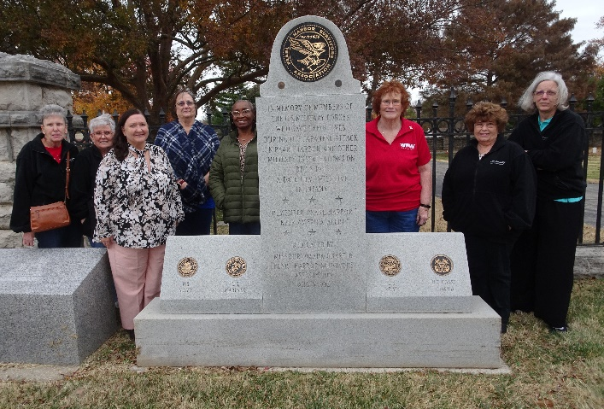

Pictured above are members who visited the Springfield National Cemetery with National President Carla Martinez. Pat Simpson, Anita Crowell, Betty Rinck, Patti Burge, Judi Linneberger, Coletta Williams, Nancy Smith, and Jackie Davis.

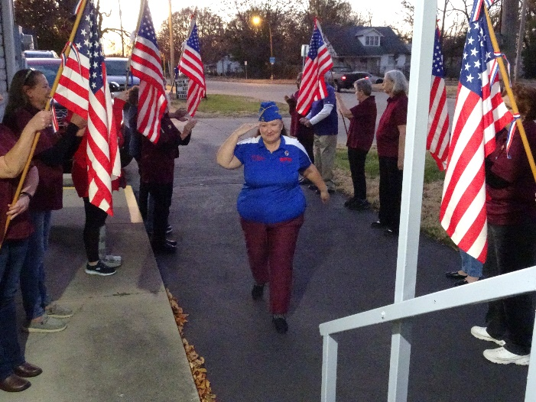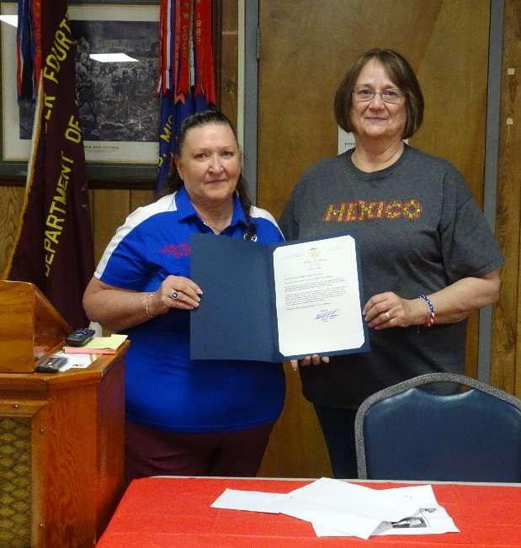

The Veterans Memorial Museum in Branson was very educational. Then onto Heroes for lunch and a Ferris wheel ride overlooking Branson. We then went back to Springfield to get ready to go to Post 3404 where we held an “Aisle of Honor” for our National President. We then had dinner at the Post, followed by a proclamation give to our National President. Several of the members enjoyed the painting of a door hanger for Christmas.